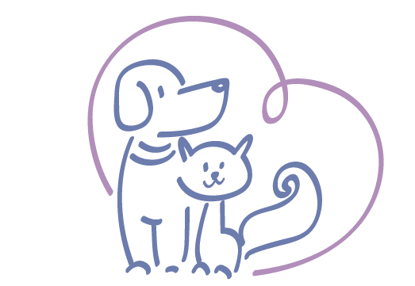

Animal Care Center
Prattville, AL

Our doggie daycare at Animal Care Center is a safe place where your pet can play, socialize and exercise while you are away at work for the day. We will place your pet in a group setting once we have evaluated your pet’s personality, energy level and any medical issues. Some pets may not “play” well with others and it is our goal to gradually introduce them to a play group. While in groups, pets are supervised at all times, however injuries may occur. We do our absolute best to minimize these incidents. We will provide fun activities for them customized to their needs. It is our goal for them to leave our facility and Wag More and Bark Less!

To achieve our goal, we need to get some information about your dog. Please assist us in answering the following questions.

Does your dog growl or become aggressive around food or toys?
________________________________________________________________________________________________________________________________________________________

Does you dog share well with others? Y or N

Can your dog climb or jump a fence? Y or N

Does your dog have any of these issues?
(Please Circle)

Aggression Excessive Barking Separation Anxiety Possessive Noise Phobia
Chews Digs Jumper Stool Eating Shy

Can we give your dog treats approved by Dr. Moody? Y or N

Does your dog know any tricks? Y or N

Anything you would like us to help with? (i.e. basic commands or housebreaking)
________________________________________________________________________________________________________________________________________________________

Medications: Special Instructions or Restrictions:
__________________________ ___________________________
__________________________ ___________________________
__________________________ ___________________________

*** Please understand if your dog shows repeated aggressive or menacing behavior that he/she will be moved out of a group play setting. If the behavior continues, your dog may be asked to leave the daycare program.

Policies and Guidelines

We require the following vaccines be up to date, as determined by Dr. Moody:
DHPP, Lepto, Bordetella, Influenza, Rabies

We require all animals be on monthly parasite prevention and flea prevention.
THIS IS FOR THE SAFETY of all of our daycare participants and boarding guests.

If veterinary services are not provided by Animal Care Center, then we require medical records from the veterinary hospital who provided these services or sold the preventatives.

Special veterinary services and full-service bathing is available while your pet is here with us. Please let us know if you are interested! We offer a discounted “soap and suds only” bath for $12 and 25% off full-service baths for our full-time daycare participants. We also can provide daily coat brushing or tooth brushing for $5/ day.

We provide all bedding and bowls to ensure proper sanitizing and to prevent lost items.

Reservations are highly recommended and availability is on a first come, first served basis. Cancellations should be made 24 hours in advance, otherwise you may be charged a “no- show” fee.

Our daycare hours are 7:30 am to 5:30 pm. Daily pick up is from 4:30-5:30. If you will need early pick up, you must let us know at the drop off time. If you are unable to pick up your pet by 5:30 pm, he/she will be moved to overnight boarding and you will be responsible for additional charges.

Interested in a daycare discount?? Sign your pet up for a Preventative Care Plan. Ask us for more information!

In the event my pet becomes ill or injured, I authorize any emergency treatment and/or administration of medication deemed necessary by the attending veterinarian. Animal Care Center will always attempt to contact you before anything is done. I understand it is my responsibility to provide up to date contact information. _________ (initial)

I understand the cost of daycare and any associated charges are a lawful debt, and I promise to pay the cost of collections, attorneys fees and court costs if such become necessary. ______ (initial)

I agree to hold harmless and person who may assist in caring for my pet, or for any claim for damages to my pet and property. I also release them from any liability or responsibility for any accident, injury or illness to my pet while attending doggy daycare. _______ (initial)

I consent to photos or videos of my pet being used for online social media, websites or print and media advertising of any kind. _______ (initial)

By signing below, I acknowledge that I have read and agree to Animal Care Center’s daycare policy and pricing.

Print Name _____________________________ Pet(s)________________________________

Signature ______________________________ Date ____________________

Email address _________________________________________

